# AWS SAA PracticeExam2018-4

1. A company is planning on building a 2-tier architecture which consists of a web server and a database server. This will be hosted on EC2 Instances accordingly. The database server will experience a lot of read/write operations whereas the web server will have a standard workload. Which of the following underlying EBS volumes are optimum to use for the underlying EC2 Instances? Choose 2 answers from the options given below.

Please select :

A. General Purpose SSD for the web server

B. Provisioned IOPS for the web server

C. General Purpose SSD for the database server

D. Provisioned IOPS for the database server

**Answer – A and D**

If the database is going to have a lot of read/write requests, then the ideal solution is to have the underlying EBS Volume as Provisioned IOPS. Whereas, in case of the standard workload, General Purpose SSD should be sufficient.

The below excerpt from AWS documentation shows the different types of EBS Volumes for different workloads:

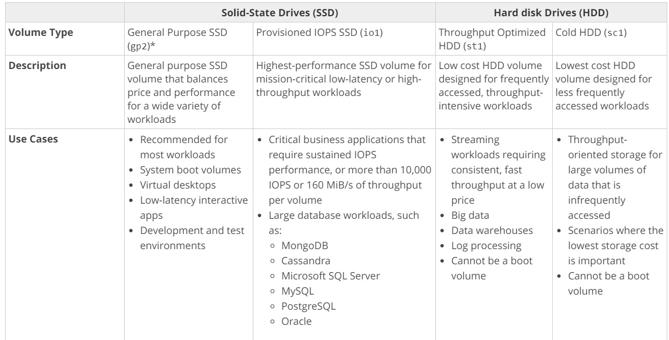

For more information on EBS Volume types, please visit the following URL:

<https://docs.aws.amazon.com/AWSEC2/latest/UserGuide/EBSVolumeTypes.html>

The correct answers are: General Purpose SSD for the web server, Provisioned IOPS for the database server

1. You are hosting a web server on an EC2 Instance. With the number of requests consuming a large part of the CPU, the response performance for the application is getting degraded. Which of the following would help alleviate the problem and provide a better response time?

Please select :

A. Place the EC2 Instance behind a Classic Load Balancer.

B. Place the EC2 Instance behind an Application Load Balancer.

C. Place the EC2 Instance in an Auto Scaling Group with the max size as 1.

D. Place a CloudFront distribution in front of the EC2 Instance.

**Answer - D**

Since there is a mention of only one EC2 instance, placing it behind the ELB would not make much sense, hence Option A and B are invalid.

Having it in an Auto Scaling Group with just one instance would not make much sense.

CloudFront distribution would help alleviate the load on the EC2 Instance because of its edge location and cache feature.

For more information on CloudFront, please visit the following URL:

<https://docs.aws.amazon.com/AmazonCloudFront/latest/DeveloperGuide/Introduction.html>

The correct answer is: Place a CloudFront distribution in front of the EC2 Instance.

1. A company is hosting a MySQL database in AWS using the AWS RDS service. To offload the reads, a Read Replica has been created and reports are run off the Read Replica database. But at certain times, the reports show stale data. Why may this be the case?

Please select :

A. The Read Replica has not been created properly.

B. The backup of the original database has not been set properly.

C. This is due to the replication lag.

D. The Multi-AZ feature is not enabled.

**Answer – C**

An AWS Whitepaper on the caveat for Read Replicas is given below which must be taken into consideration by designers:

Read Replicas are separate database instances that are replicated asynchronously. As a result, they are subject to replication lag and might be missing some of the latest transactions. Application designers need to consider which queries have tolerance to slightly stale data. Those queries can be executed on a Read Replica, while the rest should run on the primary node. Read Replicas can also not accept any write queries.

For more information on AWS Cloud best practices, please visit the following URL:

<https://d1.awsstatic.com/whitepapers/AWS_Cloud_Best_Practices.pdf>

The correct answer is: This is due to the replication lag.

1. One plans on using SQS queues and AWS Lambda to leverage the serverless aspects of the AWS Cloud. Each invocation to AWS Lambda will send a message to an SQS queue. In order for messages to be sent, which of the following must be in place?

Please select :

A. The queue must be a FIFO queue.

B. An IAM Role with the required permissions.

C. The code for Lambda must be written in C#.

D. An IAM Group with the required permissions.

**Answer – B**

While working with AWS Lambda functions, if there is a need to access other resources, ensure that an IAM role is in place. The IAM role will have the required permissions to access the SQS queue.

For more information on AWS IAM Roles, please visit the following URL:

<https://docs.aws.amazon.com/IAM/latest/UserGuide/id_roles.html>

The correct answer is: An IAM Role with the required permissions.

1. You have enabled CloudTrail logs for your company’s AWS account. In addition, the IT Security department has mentioned that the logs need to be encrypted. How can this be achieved?

Please select :

A. Enable SSL certificates for the CloudTrail logs.

B. There is no need to do anything since the logs will already be encrypted.

C. Enable Server-Side Encryption for the trail.

D. Enable Server-Side Encryption for the destination S3 bucket

**Answer – B**

AWS Documentation mentions the following:

By default, CloudTrail event log files are encrypted using Amazon S3 server-side encryption (SSE). You can also choose to encrypt your log files with an AWS Key Management Service (AWS KMS) key. You can store your log files in your bucket for as long as you want. You can also define Amazon S3 lifecycle rules to archive or delete log files automatically. If you want notifications about log file delivery and validation, you can set up Amazon SNS notifications.

For more information on how CloudTrail works, please visit the following URL:

<https://docs.aws.amazon.com/awscloudtrail/latest/userguide/how-cloudtrail-works.html>

The correct answer is: There is no need to do anything since the logs will already be encrypted.

1. A company has set up their data layer in the Simple Storage Service. There are a number of requests which include read/write and updates to objects in an S3 bucket. Users sometimes complain that updates to an object are not being reflected. Which of the following could be a reason for this?

Please select :

A. Versioning is not enabled for the bucket, so the newer version does not reflect the right data.

B. Updates are being made to the same key for the object.

C. Encryption is enabled for the bucket, hence it is taking time for the update to occur.

D. The metadata for the S3 bucket is incorrectly configured.

**Answer – B**

Updates made to objects in S3 follow an eventual consistency model. Hence, for object updates made to the same key, there can be a slight delay when the updated object is provided back to the user on the next read request.

For more information on various aspects of the Simple Storage Service, please visit the following URL:

<https://aws.amazon.com/s3/faqs/>  
The correct answer is: Updates are being made to the same key for the object.

1. A company needs to have a fully managed NoSQL database on the AWS Cloud. This database must have an ability for backups and high availability.

Which Amazon database meets these requirements?

Please select :

A. MySQL

B. Microsoft SQL Server

C. DynamoDB

D. Amazon Aurora

**Answer – C**

AWS Documentation mentions the following:

Amazon DynamoDB is a fully managed NoSQL database service that provides fast and predictable performance with seamless scalability. DynamoDB lets you offload the administrative burdens of operating and scaling a distributed database, so that you don't have to worry about hardware provisioning, setup and configuration, replication, software patching, or cluster scaling.

For more information on AWS DynamoDB, please visit the following URL:

<https://docs.aws.amazon.com/amazondynamodb/latest/developerguide/Introduction.html>

The correct answer is: DynamoDB

1. A company planning to move to the AWS Cloud, wants to leverage its existing Chef recipes for configuration management of its infrastructure. Which AWS service would be ideal for this requirement?

Please select :

A. AWS Elastic Load Balancer

B. AWS Elastic Beanstalk

C. AWS OpsWorks

D. AWS Inspector

**Answer – C**

AWS Documentation mentions the following to support this requirement:

AWS OpsWorks is a configuration management service that helps you configure and operate applications in a cloud enterprise by using Puppet or Chef. AWS OpsWorks Stacks and AWS OpsWorks for Chef Automate let you use Chef cookbooks and solutions for configuration management, while AWS OpsWorks for Puppet Enterprise lets you configure a Puppet Enterprise master server in AWS. Puppet offers a set of tools for enforcing the desired state of your infrastructure, and automating on-demand tasks.

For more information on AWS OpsWorks, please visit the following URL:

<https://docs.aws.amazon.com/opsworks/latest/userguide/welcome.html>  
The correct answer is: AWS OpsWorks

1. An application consists of a web server and database server hosted on separate EC2 Instances. There are lot of read requests on the database which is degrading the performance of the application. Which of the following can help improve the performance of the database under this heavy load?

Please select :

A. Enable Multi-AZ for the database.

B. Put an ElastiCache in front of the database.

C. Place another web server in the architecture to take the load.

D. Place a CloudFront distribution in front of the database.

**Answer - B**

The ideal solution would be to use ElastiCache.

AWS Documentation further mentions the following with respect to ElastiCache:

ElastiCache is a web service that makes it easy to set up, manage, and scale a distributed in-memory data store or cache environment in the cloud. It provides a high-performance, scalable, and cost-effective caching solution, while removing the complexity associated with deploying and managing a distributed cache environment.

For more information on AWS ElastiCache, please visit the following URL:

<https://docs.aws.amazon.com/AmazonElastiCache/latest/UserGuide/WhatIs.html>

The correct answer is: Put an ElastiCache in front of the database.

1. You need to have the ability to archive documents in AWS. This needs to be a cost-effective solution. Which of the following would you use to meet this requirement?

Please select :

A. Amazon Glacier

B. Amazon S3 Standard Infrequent Access

C. Amazon EFS

D. Amazon S3 Standard

#### Feedback

Your answer is correct.

**Answer – A**

AWS Documentation mentions the following on Amazon Glacier:

Amazon Glacier is an extremely low-cost storage service that provides durable storage with security features for data archiving and backup. With Amazon Glacier, customers can store their data cost effectively for months, years, or even decades. Amazon Glacier enables customers to offload the administrative burdens of operating and scaling storage to AWS, so they don't have to worry about capacity planning, hardware provisioning, data replication, hardware failure detection and recovery, or time-consuming hardware migrations.

For more information on Amazon Glacier, please visit the following URL:

<https://docs.aws.amazon.com/amazonglacier/latest/dev/introduction.html>

The correct answer is: Amazon Glacier

1. You plan on hosting a web application consisting of a web server and a database server. These servers are going to be hosted on different EC2 Instances in different subnets in a VPC. Which of the following can be used to ensure that the database server only allows traffic from the web server?

Please select :

A. Make use of Security Groups.

B. Make use of VPC Flow Logs.

C. Make use of Network Access Control Lists.

D. Make use of IAM Roles.

**Answer – A**

Security groups can be used to control traffic into an EC2 Instance.

The below snapshot from AWS Documentation shows the rules tables for security groups in a sample web and database server setup:

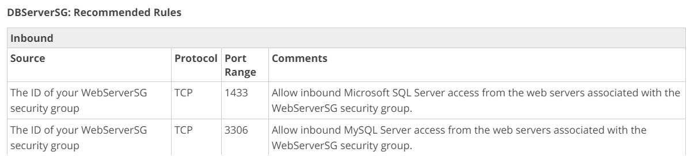

For more information on this use case scenario, please visit the following URL:

<https://docs.aws.amazon.com/AmazonVPC/latest/UserGuide/VPC_Scenario2.html>

The correct answer is: Make use of Security Groups.

1. Your IT Supervisor is worried about users accidentally deleting objects in an S3 bucket. Which of the following can help prevent accidental deletion of objects in an S3 bucket? Choose 2 answers from the options given below.

Please select :

A. Enable encryption for the S3 bucket.

B. Enable MFA Delete on the S3 bucket.

C. Enable Versioning on the S3 bucket.

D. Enable IAM Roles on the S3 bucket.

**Answer – B and C**

AWS Documentation mentions the following:

When a user performs a DELETE operation on an object, subsequent simple (un-versioned) requests will no longer retrieve the object. However, all versions of that object will continue to be preserved in your Amazon S3 bucket and can be retrieved or restored.

Versioning’s MFA Delete capability, which uses multi-factor authentication, can be used to provide an additional layer of security. By default, all requests to your Amazon S3 bucket require your AWS account credentials. If you enable Versioning with MFA Delete on your Amazon S3 bucket, two forms of authentication are required to permanently delete a version of an object: your AWS account credentials and a valid six-digit code and serial number from an authentication device in your physical possession.

For more information on the features of S3, please visit the following URL:

<https://aws.amazon.com/s3/faqs/>

The correct answers are: Enable MFA Delete on the S3 bucket., Enable Versioning on the S3 bucket.

1. A company has an application that uses the S3 bucket as its data layer. As per the monitoring on the S3 bucket, it can be seen that the number of GET requests is 400 requests per second. The IT Operations team receives service requests about users getting HTTP 500 or 503 errors while accessing the application. What can be done to resolve these errors? Choose 2 answers from the options given below.

Please select :

A. Add a CloudFront distribution in front of the bucket.

B. Add randomness to the key names.

C. Add an ELB in front of the S3 bucket.

D. Enable Versioning for the S3 bucket.

**Answer – A and B**

AWS Documentation mentions the following:

When your workload is sending mostly GET requests, you can add randomness to key names. In addition, you can integrate Amazon CloudFront with Amazon S3 to distribute content to your users with low latency and a high data transfer rate.

For more information on S3 bucket performance, please visit the following URL:

<https://docs.aws.amazon.com/AmazonS3/latest/dev/PerformanceOptimization.html>  
  
The correct answers are: Add a CloudFront distribution in front of the bucket., Add randomness to the key names.

1. A company has a Redshift Cluster defined in AWS. The IT Operations team have ensured that both automated and manual snapshots are in place. Since the cluster is going to be run for a long duration of a couple of years, Reserved Instances have been purchased. There has been a recent concern on the cost being incurred by the cluster. Which of the following steps can be carried out to minimize the costs being incurred by the cluster?

Please select :

A. Delete the manual snapshots.

B. Set the retention period of the automated snapshots to 35 days.

C. Choose to use Spot Instances instead of Reserved Instances.

D. Choose to use Instance store volumes to store the cluster data.

**Answer - A**

AWS Documentation mentions the following:

Regardless of whether you enable automated snapshots, you can take a manual snapshot whenever you want. Amazon Redshift will never automatically delete a manual snapshot. Manual snapshots are retained even after you delete your cluster.

Because manual snapshots accrue storage charges, it’s important that you manually delete them if you no longer need them.

For more information on working with Snapshots, please visit the following URL:

<https://docs.aws.amazon.com/redshift/latest/mgmt/working-with-snapshots.html>

The correct answer is: Delete the manual snapshots.

1. A company has a collection of EC2 Instances that are backed by EBS Volumes. The IT policy of the company states that all data must be backed up in an efficient manner. What is the MOST resilient way to backup the volumes?

Please select :

A. Take regular EBS Snapshots.

B. Enable EBS Volume Encryption.

C. Create a script to copy data to an EC2 Instance store.

D. Mirror data across 2 EBS Volumes.

**Answer – A**

Option B is incorrect because it does not help in the durability of EBS Volumes.

Option C is incorrect since EC2 Instance Stores are not durable.

Option D is incorrect since mirroring data across EBS Volumes is inefficient, when you already have the option for EBS Snapshots.

AWS Documentation mentions the following on AWS EBS Snapshots:

You can back up the data on your Amazon EBS Volumes to Amazon S3 by taking point-in-time snapshots. Snapshots are *incremental*backups, which means that only the blocks on the device that have changed after your most recent snapshot are saved. This minimizes the time required to create the snapshot and saves on storage costs by not duplicating data. When you delete a snapshot, only the data unique to that snapshot is removed. Each snapshot contains all of the information needed to restore your data (from the moment when the snapshot was taken) to a new EBS Volume.

For more information on AWS EBS Snapshots, please visit the following URL:

<https://docs.aws.amazon.com/AWSEC2/latest/UserGuide/EBSSnapshots.html>

The correct answer is: Take regular EBS Snapshots.

1. A company currently hosts a lot of data on their On-premise location. They want to start storing backups of this data on AWS. How can this be achieved in the most efficient way possible?

Please select :

A. Create EBS Volumes and store the data.

B. Create EBS Snapshots and store the data.

C. Make use of Storage Gateway Stored volumes.

D. Make use of Amazon Glacier.

.

**Answer – C**

AWS Storage Gateway connects an on-premises software appliance with cloud-based storage to provide seamless integration with data security features between your on-premises IT environment and the AWS storage infrastructure. You can use the service to store data in the AWS Cloud for scalable and cost-effective storage that helps maintain data security.  
  
It has two types of configuration, cached volumes, and stored volumes.   
  
Our requirement is to**start storing backups of the on-premise data to S3.**  
  
In **cached** volumes, you store your data in S3 and retain a copy of frequently accessed data subsets locally. This means that we are not storing the backups on S3 but the **actual primary data**itself.  
But in the **stored**mode, **your primary data is stored locally a**nd your entire dataset is available for low-latency access while **asynchronously backed up to AWS S3.**  
The correct answer is: Make use of Storage Gateway Stored volumes.

1. A company is planning on moving their PostgreSQL database to AWS.  They want to have the ability to have Replicas for the database and automated backup. Which of the following databases would be ideal for this scenario?

Please select :

A. AWS Aurora

B. AWS PostgreSQL

C. AWS DynamoDB

D. AWS Redshift

**Answer - A**

AWS Documentation mentions the following on Amazon Aurora:

Amazon Aurora is a drop-in replacement for MySQL and PostgreSQL. The code, tools and applications you use today with your existing MySQL and PostgreSQL databases can be used with Amazon Aurora.

For more information on Amazon Aurora, please visit the following URL:

<https://docs.aws.amazon.com/AmazonRDS/latest/UserGuide/Aurora.Overview.html>

The correct answer is: AWS Aurora

1. You currently have a set of Lambda functions which have business logic embedded in them. You want customers to have the ability to call these functions via HTTPS. How can this be achieved?

Please select :

A. Use the API Gateway and provide integration with the AWS Lambda functions.

B. Enable HTTP access on the AWS Lambda functions.

C. Add EC2 Instances with an API server installed. Integrate the server with AWS Lambda functions.

D. Use S3 websites to make calls to the Lambda functions

**Answer - A**

An API Gateway provides the ideal access to your back end services via APIs.

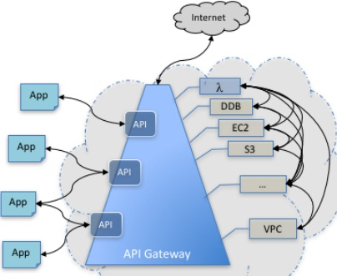

For more information on the API Gateway service, please visit the following URL:

<https://docs.aws.amazon.com/apigateway/latest/developerguide/welcome.html>  
The correct answer is: Use the API Gateway and provide integration with the AWS Lambda functions.

1. Users within a company need a place to store their documents. Each user must have his/her own location for placing the set of documents and should not be able to view another person’s documents. Also, users should be able to retrieve their documents easily. Which AWS service would be ideal for this requirement?

Please select :

A. AWS Simple Storage Service

B. AWS Glacier

C. AWS Redshift

D. AWS RDS MySQL

**Answer – A**

The Simple Storage Service is the perfect place to store the documents. You can define buckets for each user and have policies which restrict access so that each user can only access his/her own files.

For more information on the S3 service, please visit the following URL:

<https://aws.amazon.com/s3/>

The correct answer is: AWS Simple Storage Service

1. A Solutions Architect is designing a solution to store and archive corporate documents and has determined that Amazon Glacier is the right solution. Data has be retrieved within 3-5 hrs as directed by the management.

Which feature in Amazon Glacier can help meet this requirement and ensure cost-effectiveness?

Please select :

A. Vault Lock

B. Expedited retrieval

C. Bulk retrieval

D. Standard retrieval

**Answer – D**

AWS Documentation mentions the following on Standard retrievals:

Standard retrievals are a low-cost way to access your data within just a few hours. For example, you can use Standard retrievals to restore backup data, retrieve archived media content for same-day editing or distribution, or pull and analyze logs to drive business decisions within hours.

For more information on Amazon Glacier retrievals, please visit the following URL:

<https://aws.amazon.com/glacier/faqs/#dataretrievals>  
The correct answer is: Standard retrieval

1. You currently have an EC2 instance hosting a web application. The number of users is expected to increase in the coming months and hence, you need to add more elasticity to your setup. Which of the following methods can help add elasticity to your existing setup? Choose 2 answers from the options given below.

Please select :

A. Set up your web app on more EC2 instances and set them behind an Elastic Load Balancer.

B. Set up an ElastiCache in front of the EC2 instance.

C. Set up your web app on more EC2 instances and use Route 53 to route requests accordingly.

D. Set up DynamoDB behind your EC2 Instances.

**Answer – A and C**

The Elastic Load Balancer can be used to distribute traffic to EC2 Instances. So, to add elasticity to your setup, one can either do this, or even use Route 53. In Route 53, you can setup weighted routing policies to distribute requests to multiple EC2 Instances.

For more information on architecting for the cloud, please visit the following URL:

<https://aws.amazon.com/whitepapers/architecting-for-the-aws-cloud-best-practices/>

The correct answers are: Set up your web app on more EC2 instances and set them behind an Elastic Load Balancer., Set up your web app on more EC2 instances and use Route 53 to route requests accordingly.

1. A company is hosting EC2 instances which focus on work-loads for non-production and non-priority batch loads. Also, these processes can be interrupted at any time. What is the best pricing model that can be used for EC2 instances in this case?

Please select :

A. Reserved instances

B. On-Demand instances

C. Spot instances

D. Regular instances

**Answer – C**

Spot instances enable you to bid on unused EC2 instances, which can lower your Amazon EC2 costs significantly. The hourly price for a Spot instance (of each instance type in each Availability Zone) is set by Amazon EC2, and fluctuates depending on the supply of and demand for Spot instances. Your Spot instance runs whenever your bid exceeds the current market price.

Spot instances are a cost-effective choice if you can be flexible about when your applications run and if your applications can be interrupted. For example, Spot instances are well-suited for data analysis, batch jobs, background processing, and optional tasks.

Option A is invalid because even though Reserved instances can reduce costs, it's best for workloads that would be active for longer periods of time rather than for batch load processes which could last for a shorter period.

Option B is not right because On-Demand instances tend to be more expensive than Spot Instances.

Option D is invalid because there is no concept of Regular instances in AWS.

For more information on Spot instances, please visit the below URL:

<http://docs.aws.amazon.com/AWSEC2/latest/UserGuide/using-spot-instances.html>

The correct answer is: Spot instances

1. A company wants to deploy Docker containers to the AWS Cloud. They also want a highly scalable service which can help manage the orchestration of these containers. Which of the following would be ideal for such a requirement?

Please select :

A. Use the Amazon Elastic Container Service for Kubernetes.

B. Install a custom orchestration tool on EC2 Instances.

C. Use SQS to orchestrate the messages between Docker containers.

D. Use AWS Lambda functions to embed the logic for container orchestration.

**Answer – A**

AWS Documentation mentions the following;

Amazon Elastic Container Service for Kubernetes (Amazon EKS) is a managed service that makes it easy for you to run Kubernetes on AWS without needing to install and operate your own Kubernetes clusters. Kubernetes is an open-source system for automating the deployment, scaling, and management of [containerized](https://aws.amazon.com/what-are-containers/) applications. Operating Kubernetes for production applications presents a number of challenges. You need to manage the scaling and availability of your Kubernetes masters and persistence layer by ensuring that you have chosen appropriate instance types, running them across multiple Availability Zones, monitoring their health, and replacing unhealthy nodes. You need to patch and upgrade your masters and worker nodes to ensure that you are running the latest version of Kubernetes. This all requires expertise and a lot of manual work. With Amazon EKS, upgrades and high availability are managed for you by AWS. Amazon EKS runs three Kubernetes masters across three Availability Zones in order to ensure high availability. Amazon EKS automatically detects and replaces unhealthy masters, and it provides automated version upgrades and patching for the masters.

For more information on the Elastic Container Service, please visit the below URL:

<https://aws.amazon.com/eks/>

The correct answer is: Use the Amazon Elastic Container Service for Kubernetes.

1. Which of the following AWS services should be implemented in multiple Availability Zones for high availability solutions? Choose 2 answers from the options below.

Please select :

A. Amazon DynamoDB

B. Amazon Elastic Compute Cloud (EC2)

C. Amazon Elastic Load Balancing

D. Amazon Simple Storage Service (S3)

**Answer – B and C**

In the Well architectured Framework White paper under the best practice guidelines it is stated that:  
  
The following services can be deployed to multiple Availability Zones; Multiple AWS Regions if required for distributing workload load across multiple Availability Zones and AWS Regions (for example, DNS, ELB, Application Load Balancer, API Gateway, EC2).

* <https://d1.awsstatic.com/whitepapers/architecture/AWS_Well-Architected_Framework.pdf>

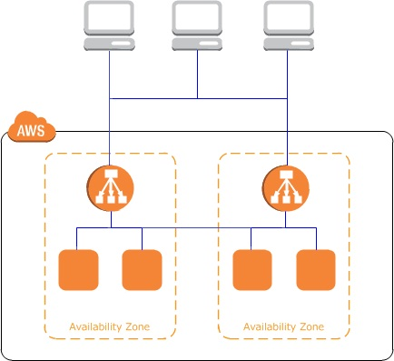

For more information on the ELB, please visit the below URL:

<https://aws.amazon.com/elasticloadbalancing/>

Option A is wrong because the service runs across Amazon’s proven, high-availability data centers. The service replicates data across three facilities in an AWS Region to provide fault tolerance in the event of a server failure or Availability Zone outage.

Option D is wrong because Amazon S3 Standard and Standard-IA redundantly stores your objects on multiple devices across multiple facilities in an Amazon S3 Region. The service is designed to sustain concurrent device failures by quickly detecting and repairing any lost redundancy.

The correct answers are: Amazon Elastic Compute Cloud (EC2), Amazon Elastic Load Balancing

1. You have created your own VPC and subnet in AWS and launched an instance in that subnet. On attaching an Internet Gateway to the VPC, you see that the instance has a public IP. The route table is shown below:

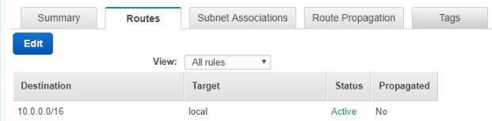

The instance still cannot be reached from the Internet. Which of the below changes need to be made to the route table to ensure that the issue is resolved?  
Please select :

A. Add the following entry to the route table – 0.0.0.0/0->Internet Gateway

B. Modify the above route table – 10.0.0.0/16 ->Internet Gateway

C. Add the following entry to the route table – 10.0.0.0/16 ->Internet Gateway

D. Add the following entry to the route table - 0.0.0.0/16->Internet Gateway

**Answer – A**

The route table needs to be modified as shown below to ensure that routes from the Internet reach the instance:

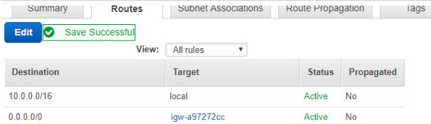

Hence by default, all other options become invalid.

For more information on Route Tables, please visit the below URL:

<http://docs.aws.amazon.com/AmazonVPC/latest/UserGuide/VPC_Route_Tables.html>

The correct answer is: Add the following entry to the route table – 0.0.0.0/0->Internet Gateway

1. Your company’s management team has asked you to devise a disaster recovery strategy for the current resources hosted in AWS. They want to minimize costs, but be able to spin up the infrastructure when needed in another region. How could you accomplish this with the LEAST costs in mind?

Please select :

A. Create a duplicate of the entire infrastructure in another region.

B. Create a Pilot Light infrastructure in another region.

C. Use Elastic Beanstalk to create another copy of the infrastructure in another region if a disaster occurs in the primary region.

D. Use CloudFormation to spin up resources in another region if a disaster occurs in the primary region.

**Answer – D**

Since cost is a factor, both options A and B are invalid.

The best and most cost effective option is to create CloudFormation templates which can be used to spin up resources in another region during disaster recovery.

For more information on CloudFormation, please visit the below URL:

<https://aws.amazon.com/cloudformation/>

The correct answer is: Use CloudFormation to spin up resources in another region if a disaster occurs in the primary region

1. You create an Auto Scaling Group which is used to spin up instances On Demand. As an architect, you need to ensure that the instances are pre-installed with a software when they are launched. What are the ways in which you can achieve this? Choose 2 answers from the options given below.

Please select :

A. Add the software installation to the configuration for the Auto Scaling Group.

B. Add the scripts for the installation in the User data section.

C. Create a golden image and then create a launch configuration.

D. Ask the IT operations team to install the software as soon as the instance is launched.

**Answer – B and C**

The User data section of an instance launch can be used to pre-configure software after the instance is initially booted.

For more information on User data, please visit the below URL:

<https://docs.aws.amazon.com/AWSEC2/latest/UserGuide/user-data.html>

Also, you can create an AMI or a golden image with the already installed software, then create a launch configuration which can be used by that Auto Scaling Group.

For more information on AMIs please visit the below URL:

<https://docs.aws.amazon.com/AWSEC2/latest/UserGuide/AMIs.html>

The correct answers are: Add the scripts for the installation in the User data section., Create a golden image and then create a launch configuration.

1. You are building a stateless architecture for an application which will consist of web servers and an Auto Scaling Group. Which of the following would be an ideal storage mechanism for Session data?

Please select :

A. AWS DynamoDB

B. AWS Redshift

C. AWS EBS Volumes

D. AWS S3

**Answer – A**

The below diagram from AWS Documentation shows how stateless architecture would look like:

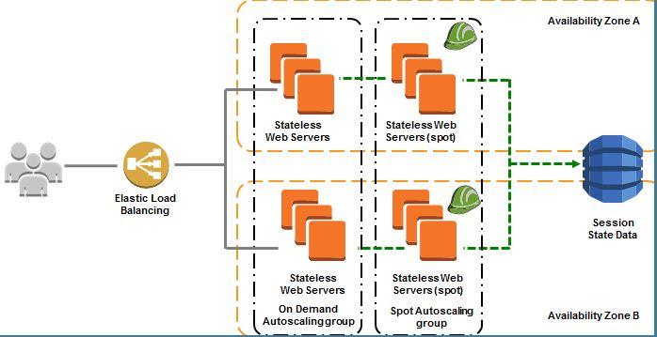

For more information on architecting for the cloud, please visit the below URL:

<https://aws.amazon.com/whitepapers/architecting-for-the-aws-cloud-best-practices/>  
The correct answer is: AWS DynamoDB

1. You have a set of IIS Servers running on EC2 Instances. You want to collect and process the log files generated from these IIS Servers. Which of the below services is ideal to run in this scenario?

Please select :

A. Amazon S3 for storing the log files and Amazon EMR for processing the log files.

B. Amazon S3 for storing the log files and EC2 Instances for processing the log files.

C. Amazon EC2 for storing and processing the log files.

D. Amazon DynamoDB to store the logs and EC2 for running custom log analysis scripts.

**Answer – A**

Amazon EMR is a managed cluster platform that simplifies running big data frameworks, such as Apache Hadoop and Apache Spark, on AWS to process and analyze vast amounts of data. By using these frameworks and related open-source projects, such as Apache Hive and Apache Pig, you can process data for analytics purposes and business intelligence workloads. Additionally, you can use Amazon EMR to transform and move large amounts of data into and out of other AWS data stores and databases, such as Amazon Simple Storage Service (Amazon S3) and Amazon DynamoDB.

Options B and C, though partially correct would be an overhead for EC2 Instances to process log files when you already have a ready made service to help in this regard.

Option D is in invalid because DynamoDB is not an ideal option to store log files.

For more information on EMR, please visit the below URL:

<http://docs.aws.amazon.com/emr/latest/ManagementGuide/emr-what-is-emr.html>  
The correct answer is: Amazon S3 for storing the log files and Amazon EMR for processing the log files.

1. You need to ensure that objects in an S3 bucket are available in another region. This is because of the criticality of the data that is hosted in the S3 bucket. How can you achieve this in the easiest way possible?

Please select :

A. Enable Cross-Region Replication for the bucket.

B. Write a script to copy the objects to another bucket in the destination region.

C. Create an S3 snapshot in the destination region.

D. Enable versioning which will copy the objects to the destination region.

**Answer – A**

AWS Documentation mentions the following:

Cross-Region Replication is a bucket-level configuration that enables automatic, asynchronous copying of objects across buckets in different AWS Regions.

For more information on Cross-Region Replication in the Simple Storage Service, please visit the below URL:

<https://docs.aws.amazon.com/AmazonS3/latest/dev/crr.html>  
The correct answer is: Enable Cross-Region Replication for the bucket.

1. You want to build and deploy code functions in the AWS Cloud, but do not want to manage the infrastructure. Which of the following services can help meet this requirement?

Please select :

A. AWS EC2

B. AWS API Gateway

C. AWS Lambda

D. AWS DynamoDB

**Answer - C**

AWS Documentation mentions the following:

AWS Lambda is a compute service that lets you run code without provisioning or managing servers. AWS Lambda executes your code only when needed and scales automatically, from a few requests per day to thousands per second. You pay only for the compute time you consume - there is no charge when your code is not running. With AWS Lambda, you can run code for virtually any type of application or backend service - all with zero administration.

For more information on AWS Lambda, please visit the below URL:

<https://docs.aws.amazon.com/lambda/latest/dg/welcome.html>  
The correct answer is: AWS Lambda

1. A storage solution is required in AWS to store videos uploaded by the user. After a period of a month, these videos can be deleted. How should this be implemented in an cost-effective manner?

Please select :

A. Use EBS Volumes to store the videos. Create a script to delete the videos after a month.

B. Use transition rule in S3 to move the files to Glacier and use expiration rule to delete it after 30 days.

C. Store the videos in Amazon Glacier and then use Lifecycle Policies.

D. Store the videos using Stored Volumes. Create a script to delete the videos after a month.

**Answer – B**

AWS Documentation mentions the following on Lifecycle Policies:

Lifecycle configuration enables you to specify the lifecycle management of objects in a bucket. The configuration is a set of one or more rules, where each rule defines an action for Amazon S3 to apply to a group of objects. These actions can be classified as follows:

* Transition actions – In which you define when objects transition to another storage class. For example, you may choose to transition objects to the STANDARD_IA (IA, for infrequent access) storage class 30 days after creation, or archive objects to the GLACIER storage class one year after creation.
* Expiration actions – In which you specify when the objects expire. Then Amazon S3 deletes the expired objects on your behalf.

 For more information on AWS S3 Lifecycle policies, please visit the following URL:

<https://docs.aws.amazon.com/AmazonS3/latest/dev/object-lifecycle-mgmt.html>  
  
**Note:**Yes, if we delete the data within 30 days, we will incur certain charges. And the question says that "How should this be implemented in an cost-effective manner?" The charge which is going to incur because of not storing data for 90 days in Glacier is would be less than storing in S3.   
  
Further, in the given options we need to choose the cost-effective option, that doesn't mean it has to be the most cost-effective.  
The correct answer is: Use transition rule in S3 to move the files to Glacier and use expiration rule to delete it after 30 days.

1. You want to keep a check on the Active EBS Volumes, Active Snapshots and Elastic IP Addresses you use, to ensure you don’t go beyond the service limit. Which of the below services can help in this regard?

Please select :

A. AWS CloudWatch

B. AWS EC2

C. AWS Trusted Advisor

D. AWS SNS

**Answer – C**

Below is a snapshot of the service limits that the Trusted Advisor can monitor:

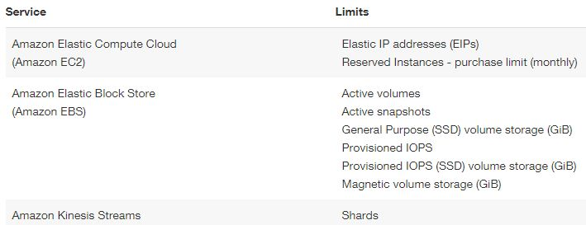

Option A is invalid because even though you can monitor resources, it cannot be checked against the service limit.

Option B is invalid because this is the Elastic Compute Cloud service.

Option D is invalid because it can be used to send notifications but not to check on service limits.

For more information on Trusted Advisor monitoring, please visit the below URL:

<https://aws.amazon.com/premiumsupport/ta-faqs/>

The correct answer is: AWS Trusted Advisor

1. You have an EC2 Instance in a particular region. This EC2 Instance has a preconfigured software running on it. You have been requested to create a disaster recovery solution in case the instance in the region fails. Which of the following is the best solution?

Please select :

A. Create a duplicate EC2 Instance in another AZ. Keep it in the shutdown state. When required, bring it back up.

B. Backup the EBS data volume. If the instance fails, bring up a new EC2 instance and attach the volume.

C. Store the EC2 data on S3. If the instance fails, bring up a new EC2 instance and restore the data from S3.

D. Create an AMI of the EC2 Instance and copy it to another region.

**Answer - D**

You can copy an Amazon Machine Image (AMI) within or across an AWS region using the AWS Management Console, the AWS command line tools or SDKs, or the Amazon EC2 API, all of which support the CopyImage action. You can copy both Amazon EBS-backed AMIs and instance store-backed AMIs. You can copy AMIs with encrypted snapshots and encrypted AMIs.

Copying a source AMI results in an identical but distinct target AMI with its own unique identifier. In the case of an Amazon EBS-backed AMI, each of its backing snapshots is, by default, copied to an identical but distinct target snapshot.

Option A is invalid, because it is a maintenance overhead to maintain another non-running instance.

Option B is invalid, because the preconfigured software could have settings on the root volume.

Option C is invalid, because this is a long and inefficient way to restore a failed instance.

For more information on Copying AMIs, please visit the below URL:

<http://docs.aws.amazon.com/AWSEC2/latest/UserGuide/CopyingAMIs.html>

The correct answer is: Create an AMI of the EC2 Instance and copy it to another region.

1. You work in the media industry and have created a web application where users will be able to upload photos they create to your website. This web application must be able to call the S3 API in order to be able to function. Where should you store your API credentials whilst maintaining the maximum level of security?

Please select :

A. Save the API credentials to your PHP files.

B. Don’t save your API credentials. Instead create a role in IAM and assign this role to an EC2 instance when you first create it.

C. Save your API credentials in a public Github repository.

D. Pass API credentials to the instance using instance user data.

#### Feedback

Your answer is correct.

**Answer – B**

Applications must sign their API requests with AWS credentials. Therefore, if you are an application developer, you need a strategy for managing credentials for your applications that run on EC2 instances. For example, you can securely distribute your AWS credentials to the instances, enabling the applications on those instances to use your credentials to sign requests, while protecting your credentials from other users. However, it's challenging to securely distribute credentials to each instance, especially those that AWS creates on your behalf, such as Spot Instances or instances in Auto Scaling groups. You must also be able to update the credentials on each instance when you rotate your AWS credentials.

IAM roles are designed so that your applications can securely make API requests from your instances, without requiring you to manage the security credentials that the applications use.

For more information on IAM Roles, please visit the below URL:

<http://docs.aws.amazon.com/AWSEC2/latest/UserGuide/iam-roles-for-amazon-ec2.html>  
The correct answer is: Don’t save your API credentials. Instead create a role in IAM and assign this role to an EC2 instance when you first create it.

1. You need to ensure that data stored in S3 is encrypted but do not want to manage the encryption keys. Which of the following encryption mechanisms can be used in this case?

Please select :

A. SSE-S3

B. SSE-C

C. SSE-KMS

D. SSE-SSL

**Answer - A**

AWS Documentation mentions the following on Encryption keys:

* SSE-S3 requires that Amazon S3 manages the data and master encryption keys.
* SSE-C requires that you manage the encryption keys.
* SSE-KMS requires that AWS manages the data key but you manage the master key in AWS KMS.

 For more information on using the Key Management service for S3, please visit the below URL:

<https://docs.aws.amazon.com/kms/latest/developerguide/services-s3.html>

1. An organization is managing a Redshift Cluster in AWS. They need to monitor the performance of this Redshift cluster to ensure that it is performing as efficiently as possible. Which of the following services can be used for achieving this requirement?

Please select :

A. CloudTrail

B. VPC Flow Logs

C. CloudWatch

D. AWS Trusted Advisor

.

**Answer - C**

AWS Documentation mentions the following on monitoring Redshift Clusters:

Amazon CloudWatch metrics help you monitor physical aspects of your cluster, such as CPU utilization, latency, and throughput. Metric data is displayed directly in the Amazon Redshift console. You can also view it in the Amazon CloudWatch console, or you can consume it in any other way you work with metrics such as with the Amazon CloudWatch Command Line Interface (CLI) or one of the AWS Software Development Kits (SDKs).

For more information on monitoring Redshift, please visit the below URL:

<https://docs.aws.amazon.com/redshift/latest/mgmt/metrics.html>  
The correct answer is: CloudWatch

1. Your company currently has an S3 bucket in AWS. The objects in S3 are accessed quite frequently. Which of the following is an implementation step that can be considered to reduce the cost of accessing contents from the S3 bucket?

Please select :

A. Place the S3 bucket behind a CloudFront distribution.

B. Enable Versioning on the S3 bucket.

C. Enable Encryption on the S3 bucket.

D. Place the S3 bucket behind an API Gateway.

**Answer - A**

AWS Documentation mentions the following:

Using CloudFront can be more cost effective if your users access your objects frequently because, at higher usage, the price for CloudFront data transfer is lower than the price for Amazon S3 data transfer. In addition, downloads are faster with CloudFront than with Amazon S3 alone because your objects are stored closer to your users.

For more information on using Cloudfront with S3, please visit the below URL:

<https://docs.aws.amazon.com/AmazonCloudFront/latest/DeveloperGuide/MigrateS3ToCloudFront.html>  
The correct answer is: Place the S3 bucket behind a CloudFront distribution.

1. You have an application in which users subscribe to a service using their email ID. They should be able to receive messages published by the service and this needs to be done using AWS Components. Which of the below would be a probable service included in this architecture?

Please select :

A. AWS SNS

B. AWS Config

C. AWS S3

D. AWS Glacier

**Answer - A**

AWS Documentation mentions the following:

Amazon Simple Notification Service (Amazon SNS) is a web service that coordinates and manages the delivery or sending of messages to subscribing endpoints or clients. In Amazon SNS, there are two types of clients—publishers and subscribers—also referred to as producers and consumers. Publishers communicate asynchronously with subscribers by producing and sending a message to a topic, which is a logical access point and communication channel. Subscribers (i.e., web servers, email addresses, Amazon SQS queues, AWS Lambda functions) consume or receive the message or notification over one of the supported protocols (i.e., Amazon SQS, HTTP/S, email, SMS, Lambda) when they are subscribed to the topic.

For more information on the Simple Notification Service, please visit the below URL:

<https://docs.aws.amazon.com/sns/latest/dg/welcome.html>

The correct answer is: AWS SNS

1. IOT sensors monitor the number of bags that are handled at an airport. The data gets sent back to a Kinesis stream with default settings. Every alternate day, the data from the stream is sent to S3 for processing. But it is noticed that S3 is not receiving all of the data that is being sent to the Kinesis stream. What could be the reason for this?

Please select :

A. The sensors probably stopped working on some days, hence data is not sent to the stream.

B. S3 can only store data for a day.

C. Data records are only accessible for a default of 24 hours from the time they are added to a stream.

D. Kinesis streams are not meant to handle IoT related data.

**Answer – C**

Kinesis Streams support changes to the data record retention period of your stream. A Kinesis stream is an ordered sequence of data records meant to be written to and read from in real-time. Data records are therefore stored in shards in your stream temporarily. The time period from when a record is added to when it is no longer accessible is called the *retention period*. A Kinesis stream stores records from 24 hours by default, up to 168 hours.

Option A, even though a possibility, cannot be taken for granted as the right option.

Option B is invalid since S3 can store data indefinitely unless you have a lifecycle policy defined.

Option D is invalid because the Kinesis service is perfect for this sort of data ingestion.

For more information on Kinesis data retention, please refer to the below URL:

<http://docs.aws.amazon.com/streams/latest/dev/kinesis-extended-retention.html>  
The correct answer is: Data records are only accessible for a default of 24 hours from the time they are added to a stream.

1. A company needs to have a columnar structured database storage suitable to perform complex analytic queries against petabytes of structured data, Which of the following options can meet this requirement?

Please select :

A. Amazon Redshift

B. Amazon RDS

C. ElastiCache

D. DynamoDB

**Answer – A**

AWS Documentation mentions the following:

Amazon Redshift is a column-oriented, fully managed, petabyte-scale data warehouse that makes it simple and cost-effective to analyze all your data using your existing business intelligence tools. Amazon Redshift achieves efficient storage and optimum query performance through a combination of massively parallel processing, columnar data storage, and very efficient, targeted data compression encoding schemes.

For more information on columnar database in AWS, please refer to the below URL:

<https://aws.amazon.com/nosql/columnar/>  
The correct answer is: Amazon Redshift

1. There is a requirement to host a database on an EC2 Instance. The EBS Volume is required to support a high rate of IOPS since a large number of read and write requests are expected on the database.

Which Amazon EBS Volume type can meet the performance requirements of this database?  
Please select :

A. EBS Provisioned IOPS SSD

B. EBS Throughput Optimized HDD

C. EBS General Purpose SSD

D. EBS Cold HDD

**Answer – A**

Since this is a high performance requirement with high IOPS needed, one should opt for EBS Provisioned IOPS SSD.

The below snapshot from the AWS Documentation mentions the need for using Provisioned IOPS for better IOPS performance in database based applications.

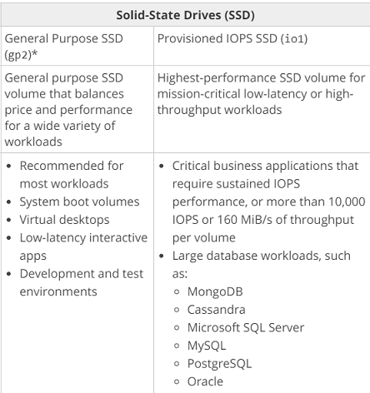

For more information on AWS EBS Volume types, please visit the following URL:

<https://docs.aws.amazon.com/AWSEC2/latest/UserGuide/EBSVolumeTypes.html>  
The correct answer is: EBS Provisioned IOPS SSD

1. You have a requirement for deploying an existing Java based application to AWS. There is a need for automatic scaling for the underlying environment. Which of the following can be used to deploy this environment in the quickest way possible?

Please select :

A. Deploy to an S3 bucket and enable web site hosting.

B. Use the Elastic Beanstalk service to provision the environment.

C. Use EC2 with Auto Scaling for the environment.

D. Use AMIs to build EC2 instances for deployment.

**Answer - B**

AWS Documentation mentions the following:

AWS Elastic Beanstalk is an easy-to-use service for deploying and scaling web applications and services developed with Java, .NET, PHP, Node.js, Python, Ruby, Go, and Docker on familiar servers such as Apache, Nginx, Passenger, and IIS.

You can simply upload your code and Elastic Beanstalk automatically handles the deployment, from capacity provisioning, load balancing, auto-scaling to application health monitoring. At the same time, you retain full control over the AWS resources powering your application and can access the underlying resources at any time.

For more information on the Elastic Beanstalk service, please visit the following URL:

<https://aws.amazon.com/elasticbeanstalk/>  
The correct answer is: Use the Elastic Beanstalk service to provision the environment

1. There is a requirement to upload a million files to S3. Which of the following can be used to ensure optimal performance?

Please select :

A. Use a date for the prefix.

B. Use a hexadecimal hash for the prefix.

C. Use a date for the suffix.

D. Use a sequential ID for the suffix.

**Answer – B**

AWS Documentation recommends the below to increase performance in case of a high request rate on S3.

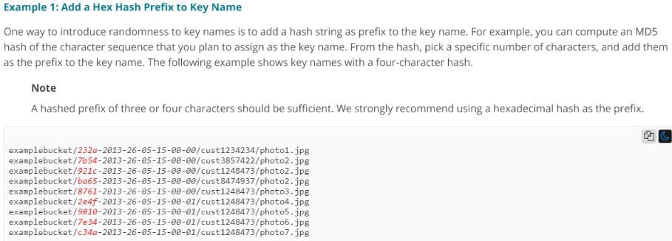

For more information on S3 performance considerations, please visit the following URL:

<https://docs.aws.amazon.com/AmazonS3/latest/dev/request-rate-perf-considerations.html>

The correct answer is: Use a hexadecimal hash for the prefix.

1. You want to build a decoupled, highly available and fault tolerant architecture for your application in AWS. You decide to use EC2, the Classic Load Balancer, Auto Scaling and Route 53. Which one of the following additional services should you involve in this architecture?

Please select :

A. AWS SNS

B. AWS SQS

C. AWS API Gateway

D. AWS Config

**Answer – B**

The Simple Queue Service can be used to build a decoupled architecture.

AWS Documentation further mentions the following:

Amazon Simple Queue Service (SQS) is a fully managed message queuing service that makes it easy to decouple and scale microservices, distributed systems, and serverless applications. Building applications from individual components that each perform a discrete function improves scalability and reliability, and is best practice design for modern applications.

For more information on the Simple Queue Service, please visit the following URL:

<https://aws.amazon.com/sqs/>  
The correct answer is: AWS SQS

1. You have been tasked with architecting an application in AWS. The architecture would consist of EC2, the Classic Load Balancer, Auto Scaling and Route 53. There is a directive to ensure that Blue-Green deployments are possible in this architecture. Which routing policy could you ideally use in Route 53 for achieving Blue-Green deployments?

Please select :

A. Simple

B. Multi-answer

C. Latency

D. Weighted

**Answer – D**

AWS Documentation mentions that Weighted routing policy is good for testing new versions of software. And that this is the ideal approach for Blue-Green deployments.

Weighted routing lets you associate multiple resources with a single domain name (example.com) or subdomain name (acme.example.com) and choose how much traffic is routed to each resource. This can be useful for a variety of purposes, including load balancing and testing new versions of software.

For more information on Route 53 routing policies, please visit the following URL:

<https://docs.aws.amazon.com/Route53/latest/DeveloperGuide/routing-policy.html>  
  
**Note:** Multivalue-answer is recommended to use only when you want to route traffic randomly to multiple resources, such as web servers, you can create one multivalue answer record for each resource and, optionally, associate an Amazon Route 53 health check with each record.  
  
However, in our case, we need to choose how much traffic is routed to each resource (blue and green). For example, Blue is currently live and we need to send less portion of traffic to Green, to check everything works fine. If yes, then we can decide to go with Green resources. If no, we can change the weight for that record to 0. Blue will be completely live again.   
The correct answer is: Weighted

1. A company is planning to deploy an application in AWS. This application requires an EC2 Instance to continuously perform log processing activities requiring at least 500MiB/s of data throughput. Which of the following is the best storage option for this requirement?

Please select :

A. EBS IOPS

B. EBS SSD

C. EBS Throughput Optimized

D. EBS Cold Storage

**Answer – C**

While considering storage volume types for batch processing activities with large throughput, consider using the EBS Throughput Optimized volume type.

AWS Documentation mentions this, as shown below:

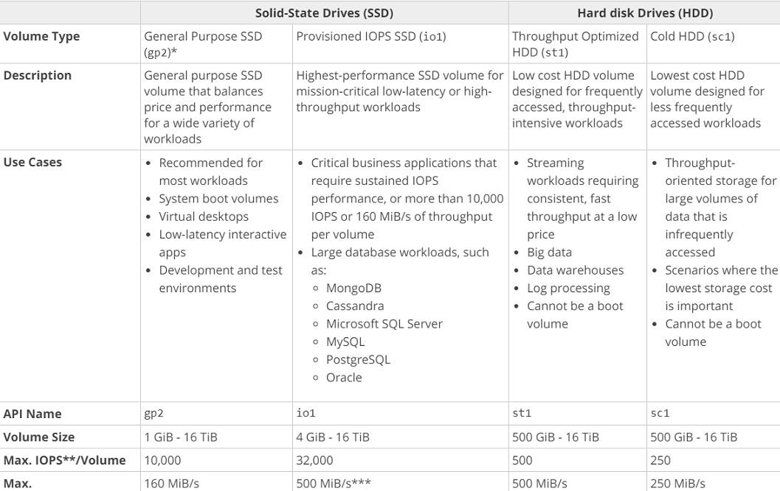

For more information on EBS Volume Types, please visit the following URL:

<https://docs.aws.amazon.com/AWSEC2/latest/UserGuide/EBSVolumeTypes.html>

The correct answer is: EBS Throughput Optimized

1. You are required to connect 2 VPCs in different accounts. How can this be achieved?

Please select :

A. Use Security Groups to map both VPCs.

B. Use the VPC Route Tables to map both VPCs.

C. Use Consolidating billing to connect both accounts.

D. Use VPC Peering to connect both VPCs.

**Answer – D**

AWS Documentation mentions the following on VPC Peering:

A VPC peering connection is a networking connection between two VPCs that enables you to route traffic between them privately. Instances in either VPC can communicate with each other as if they are within the same network. You can create a VPC peering connection between your own VPCs, with a VPC in another AWS account, or with a VPC in a different AWS Region.

For more information on VPC Peering, please visit the following URL:

<https://docs.aws.amazon.com/AmazonVPC/latest/UserGuide/vpc-peering.html>  
The correct answer is: Use VPC Peering to connect both VPCs.

1. You need to ensure that instances in a private subnet can access the Internet. The solution should be highly available and ensure less maintenance overhead. Which of the following would ideally fit this requirement?

Please select :

A. Host the NAT Instance in the private subnet.

B. Host the NAT Instance in the public subnet.

C. Use the NAT Gateway in the private subnet.

D. Use the NAT Gateway in the public subnet.

**Answer – D**

Shown below is a comparison of the NAT Gateway and NAT Instances as per the AWS Documentation. The documentation states that the NAT Gateway is highly available and requires less management.

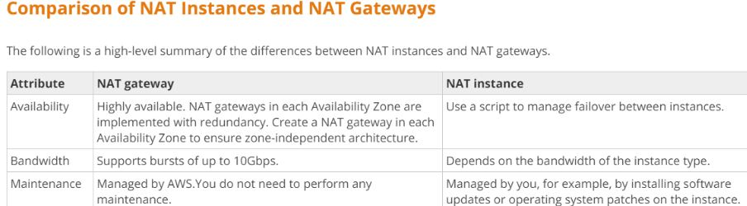

For more information on the above comparison, please visit the following URL:

<https://docs.aws.amazon.com/AmazonVPC/latest/UserGuide/vpc-nat-comparison.html>  
The correct answer is: Use the NAT Gateway in the public subnet.

1. You need to have a Data storage layer in AWS. Following are the key requirements:

a) Storage of JSON documents

b) Availability of Indexes

c) Automatic scaling

Which of the following would be an ideal storage layer for the above requirements?  
Please select :

A. AWS DynamoDB

B. AWS EBS Volumes

C. AWS S3

D. AWS Glacier

**Answer – A**

AWS Documentation mentions the following:

Amazon DynamoDB is a fully managed NoSQL database service that provides fast and predictable performance with seamless scalability. DynamoDB enables customers to offload the administrative burdens of operating and scaling distributed databases to AWS so that they don’t have to worry about hardware provisioning, setup and configuration, throughput capacity planning, replication, software patching, or cluster scaling.

For more information on DynamoDB, please visit the following URL:

<https://aws.amazon.com/dynamodb/faqs/>  
The correct answer is: AWS DynamoDB

1. You have a set of Docker images that you use for building containers. You want to start using the Elastic Container Service and utilize the Docker images. You need a place to store these Docker images. Which of the following can be used for this purpose?

Please select :

A. Use AWS DynamoDB to store the Docker images.

B. Use AWS RDS to store the Docker images.

C. Use EC2 Instances with EBS Volumes to store the Docker images.

D. Use the ECR Service to store the Docker images.

**Answer - D**

AWS Documentation mentions the following:

Amazon Elastic Container Registry (ECR) is a fully-managed Docker container registry that makes it easy for developers to store, manage, and deploy Docker container images. Amazon ECR is integrated with Amazon Elastic Container Service (ECS), simplifying your development to production workflow.

For more information on the Elastic Container Service, please visit the following URL:

<https://aws.amazon.com/ecr/?nc2=h_m1>  
The correct answer is: Use the ECR Service to store the Docker images.

1. You need to start using resources in AWS to build a big data processing system. Which one of the following services would you ideally use for this requirement?

Please select :

A. AWS DynamoDB

B. AWS EMR

C. AWS ECS

D. AWS ECR

**Answer - B**

AWS Documentation mentions the following:

Amazon EMR provides a managed Hadoop framework that makes it easy, fast, and cost-effective to process vast amounts of data across dynamically scalable Amazon EC2 instances. You can also run other popular distributed frameworks such as Apache Spark, HBase, Presto, and Flink in Amazon EMR, and interact with data in other AWS data stores such as Amazon S3 and Amazon DynamoDB.

Amazon EMR securely and reliably handles a broad set of big data use cases, including log analysis, web indexing, data transformations (ETL), machine learning, financial analysis, scientific simulation, and bioinformatics.

For more information on the EMR service, please visit the following URL:

<https://aws.amazon.com/emr/?nc2=h_m1>  
The correct answer is: AWS EMR

1. You are working on creating a mobile application for your company. This application is being built to work with DynamoDB as the back end and JavaScript as the front end. During application usage, you notice that there are spikes in the application, especially in the DynamoDB area. Which one of the below options provides the most cost-effective and scalable architecture for this application?

Please select :

A. Auto scale DynamoDB to meet the requirements.

B. Increase write capacity of DynamoDB tables to meet the peak loads.

C. Create a service that pulls SQS messages and writes these to DynamoDB to handle sudden spikes in DynamoDB.

D. Launch DynamoDB in Multi-AZ configuration with a global index to balance writes.

**Answer – C**

When looking for scalability, SQS is the best option. DynamoDB is scalable, but since a cost-effective solution is required, SQS messaging can assist in managing the above situation.

Amazon Simple Queue Service (SQS) is a fully-managed message queuing service for reliably communicating among distributed software components and microservices - at any scale. Building applications from individual components that each perform a discrete function improves scalability and reliability, and is best practice design for modern applications. SQS makes it simple and cost-effective to decouple and coordinate the components of a cloud application. Using SQS, you can send, store, and receive messages between software components at any volume, without losing messages or requiring other services to be always available.

For more information on SQS, please refer to the below URL:  
<https://aws.amazon.com/sqs/>  
The correct answer is: Create a service that pulls SQS messages and writes these to DynamoDB to handle sudden spikes in DynamoDB.

1. You are building a large-scale confidential documentation web server on AWS and all of its documentation will be stored on S3. One of the requirements is that it should not be publicly accessible from S3 directly, and CloudFront would be needed to accomplish this. Which of the methods listed below would satisfy the outlined requirements? Choose an answer from the options below.

Please select :

A. Create an Identity and Access Management (IAM) user for CloudFront and grant access to the objects in your S3 bucket to that IAM User.

B. Create an Origin Access Identity (OAI) for CloudFront and grant access to the objects in your S3 bucket to that OAI.

C. Create individual policies for each bucket the documents are stored in, and grant access only to CloudFront in these policies.

D. Create an S3 bucket policy that lists the CloudFront distribution ID as the Principal and the target bucket as the Amazon Resource Name (ARN).

**Answer – B**

If you want to use CloudFront signed URLs or signed cookies to provide access to objects in your Amazon S3 bucket, you probably also want to prevent users from accessing your Amazon S3 objects using Amazon S3 URLs. If users access your objects directly in Amazon S3, they bypass the controls provided by CloudFront signed URLs or signed cookies, for example, control over the date and time that a user can no longer access your content and control over which IP addresses can be used to access content. In addition, if users access objects both through CloudFront and directly by using Amazon S3 URLs, CloudFront access logs are less useful because they're incomplete.

For more information on Origin Access Identity, please see the below link:

<http://docs.aws.amazon.com/AmazonCloudFront/latest/DeveloperGuide/private-content-restricting-access-to-s3.html>  
The correct answer is: Create an Origin Access Identity (OAI) for CloudFront and grant access to the objects in your S3 bucket to that OAI.

1. Your company is planning on hosting their development, test and production applications on EC2 Instances in AWS. They are worried about how access control would be given to relevant IT Admins for each of the above environments. As an architect, what would you suggest for managing the relevant accesses?

Please select :

A. Add tags to the instances marking each environment and then segregate access using IAM Policies.

B. Add Userdata to the underlying instances to mark each environment.

C. Add Metadata to the underlying instances to mark each environment.

D. Add each environment to a separate Auto Scaling Group.

**Answer - A**

AWS Documentation mentions the following to support this requirement:

Tags enable you to categorize your AWS resources in different ways, for example, by purpose, owner, or environment. This is useful when you have many resources of the same type — you can quickly identify a specific resource based on the tags you've assigned to it. Each tag consists of a *key* and an optional *value*, both of which you define. For example, you could define a set of tags for your account's Amazon EC2 instances that helps you track each instance's owner and stack level. We recommend that you devise a set of tag keys that meets your needs for each resource type. Using a consistent set of tag keys makes it easier for you to manage your resources. You can search and filter the resources based on the tags you add.

For more information on using tags, please see the below link:

<https://docs.aws.amazon.com/AWSEC2/latest/UserGuide/Using_Tags.html>

The correct answer is: Add tags to the instances marking each environment and then segregate access using IAM Policies.

1. You want to set up a public website on AWS. Your requirements are as follows:

* You want the database and the application server running on AWS VPC.
* You want the database to be able to connect to the Internet, specifically for patch upgrades.
* You do not want to receive any incoming requests from the Internet to the database.

Which of the following solutions would best satisfy all the above requirements for this planned public AWS website? Choose the correct answer from the options below.

Please select :

A. Set up the database in a private subnet with a security group which only allows outbound traffic.

B. Set up the database in a public subnet with a security group which only allows inbound traffic.

C. Set up the database in a local data center and use a private gateway to connect the application to the database.

D. Set up the public website on a public subnet and set up the database in a private subnet which connects to the Internet via a NAT Instance.

**Answer – D**

The below diagram from AWS Documentation showcases this architecture:

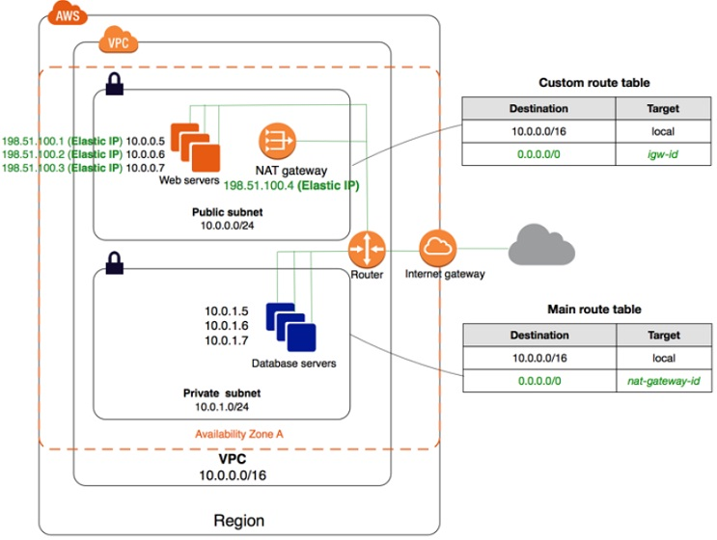

For more information on the VPC Scenario for public and private subnets, please see the below link:

<http://docs.aws.amazon.com/AmazonVPC/latest/UserGuide/VPC_Scenario2.html>  
The correct answer is: Set up the public website on a public subnet and set up the database in a private subnet which connects to the Internet via a NAT Instance

1. A company has a Redshift cluster for petabyte-scale data warehousing. The data within the cluster is easily reproducible from additional data stored on Amazon S3. The company wants to reduce the overall total cost of running this Redshift cluster. Which scenario would best meet the needs of the running cluster, while still reducing total overall ownership of the cluster? Choose the correct answer from the options below.

Please select :

A. Instead of implementing automatic daily backups, write a CLI script that creates manual snapshots every few days. Copy the manual snapshot to a secondary AWS region for disaster recovery situations.

B. Enable automated snapshots but set the retention period to a lower number to reduce storage costs.

C. Implement daily backups, but do not enable multi-region copy to save data transfer costs.

D. Disable automated and manual snapshots on the cluster.

**Answer – D**

Snapshots are point-in-time backups of a cluster. There are two types of snapshots: *automated* and *manual*. Amazon Redshift stores these snapshots internally in Amazon S3 by using an encrypted Secure Sockets Layer (SSL) connection. If you need to restore from a snapshot, Amazon Redshift creates a new cluster and imports data from the snapshot that you specify.

Since the question already mentions that the cluster is easily reproducible from additional data stored on Amazon S3, you do not need to maintain snapshots.

For more information on Redshift Snapshots, please visit the below URL:

<http://docs.aws.amazon.com/redshift/latest/mgmt/working-with-snapshots.html>  
The correct answer is: Disable automated and manual snapshots on the cluster.

1. You have an application to be setup in AWS, and the following points are to be considered:

a) A Web tier hosted on EC2 Instances

b) Session data to be written to DynamoDB

c) Log files to be written to Microsoft SQL Server

How will you ensure that the application writes data to a DynamoDB table?  
Please select :

A. Add an IAM user to a running EC2 instance.

B. Add an IAM user that allows write access to the DynamoDB table.

C. Create an IAM role that allows read access to the DynamoDB table.

D. Create an IAM role that allows write access to the DynamoDB table.

**Answer – D**

IAM roles are designed so that your applications can securely make API requests from your instances, without requiring you to manage the security credentials that the applications use. Instead of creating and distributing your AWS credentials, wean delegate permission to make API requests using IAM roles.

For more information on IAM roles, please refer to the link below:

<http://docs.aws.amazon.com/AWSEC2/latest/UserGuide/iam-roles-for-amazon-ec2.html>  
The correct answer is: Create an IAM role that allows write access to the DynamoDB table.

1. You are performing a Load Testing exercise on your application hosted on AWS. While testing your Amazon RDS MySQL DB Instance, you notice that your application becomes non responsive when you reach 100% CPU utilization. Your application is read-heavy. What methods will help scale your data-tier to meet the application’s needs? Choose three answers from the options given below.

Please select :

A. Add Amazon RDS DB Read Replicas, and have your application direct read queries to them.

B. Add your Amazon RDS DB Instance to an Auto Scaling group and configure your CloudWatch metric based on CPU utilization.

C. Use an Amazon SQS queue to throttle data going to the Amazon RDS DB Instance.

D. Use ElastiCache in front of your Amazon RDS DB to cache common queries.

E. Shard your data set among multiple Amazon RDS DB Instances.

F. Enable Multi-AZ for your Amazon RDS DB Instance.

**Answer – A, D and E**

Amazon RDS Read Replicas provide enhanced performance and durability for database (DB) instances. This replication feature makes it easy to elastically scale out beyond the capacity constraints of a single DB Instance for read-heavy database workloads. You can create one or more replicas of a given source DB Instance and serve high-volume application read traffic from multiple copies of your data, thereby increasing aggregate read throughput.

For more information on Read Replicas, please refer to the link below.

<https://aws.amazon.com/rds/details/read-replicas/>  
Sharding is a common concept to split data across multiple tables in a database.

For more information on sharding, please refer to the link below.

<https://forums.aws.amazon.com/thread.jspa?messageID=203052>  
Amazon ElastiCache is a web service that makes it easy to deploy, operate, and scale an in-memory data store or cache in the cloud. The service improves the performance of web applications by allowing you to retrieve information from fast, managed, in-memory data stores, instead of relying entirely on slower disk-based databases.

For more information on ElastiCache, please refer to the link below.

<https://aws.amazon.com/elasticache/>  
Option B is not an ideal way to scale a database.

Option C is not an ideal choice to store data going into a database because of the message size.

Option F is invalid because the Multi-AZ feature is only a failover option.  
The correct answers are: Add Amazon RDS DB Read Replicas, and have your application direct read queries to them., Use ElastiCache in front of your Amazon RDS DB to cache common queries., Shard your data set among multiple Amazon RDS DB Instances.

1. You work for a large company having multiple applications which are very different from each other. These are built using different programming languages. How can you deploy these applications as quickly as possible?

Please select :

A. Develop each app in one Docker container and deploy using Elastic Beanstalk.

B. Create a Lambda function deployment package consisting of code and any dependencies.

C. Develop each app in a separate Docker container and deploy using Elastic Beanstalk.

D. Develop each app in separate Docker containers and deploy using CloudFormation.

**Answer – C**

Elastic Beanstalk supports the deployment of web applications from Docker containers. With Docker containers, you can define your own runtime environment. You can choose your own platform, programming language, and any application dependencies (such as package managers or tools), that aren't supported by other platforms. Docker containers are self-contained and include all the configuration information and software your web application requires to run.

Option A is not suitable here, because the requirement is to deploy multiple app with different languages & very different from each other.

Option B is ideally used for running code and not packaging the applications and dependencies.

Option D - Deploying Docker containers using CloudFormation is also not an ideal choice.

For more information on Docker and Elastic Beanstalk, please visit the below URL:

<http://docs.aws.amazon.com/elasticbeanstalk/latest/dg/create_deploy_docker.html>  
The correct answer is: Develop each app in a separate Docker container and deploy using Elastic Beanstalk.

1. You are designing a system which needs at minimum, 8 m4.large instances operating to service traffic. While designing a system for high availability in the us-east-1 region having 6 Availability Zones, your company needs to be able to handle the death of a full availability zone. How should you distribute the servers to save as much cost as possible, assuming all of the EC2 nodes are properly linked to an ELB? Your VPC account can utilize us-east-1’s AZs a through f, inclusive.

Please select :

A. 3 servers in each of AZs a through d, inclusive.

B. 8 servers in each of AZs a and b.

C. 2 servers in each of AZs a through e, inclusive.

D. 4 servers in each of AZs a through c, inclusive.

**Answer – C**

The best way is to distribute the instances across multiple AZs to get the best performance and to avoid a disaster scenario.

With this solution, you will always have a minimum of more than 8 servers even if one AZ were to go down.

Even though options A and D are also valid, the best solution for distribution is Option C.

For more information on High Availability and Fault tolerance, please refer to the below link:

<https://media.amazonwebservices.com/architecturecenter/AWS_ac_ra_ftha_04.pdf>  
The correct answer is: 2 servers in each of AZs a through e, inclusive.

1. You have been given a business requirement to retain log files for your application for 10 years. You need to regularly retrieve the most recent logs for troubleshooting. Your logging system must be cost-effective, given the large volume of logs. What technique should you use to meet these requirements?

Please select :

A. Store your log in Amazon CloudWatch Logs.

B. Store your logs in Amazon Glacier.

C. Store your logs in Amazon S3, and use Lifecycle Policies to archive to Amazon Glacier.

D. Store your logs on Amazon EBS, and use Amazon EBS Snapshots to archive them.

**Answer - C**

Option A is invalid, because CloudWatch will not store the logs indefinitely and secondly because, it is not a cost-effective option.

Option B is invalid, because it will not serve the purpose of regularly retrieving the most recent logs for troubleshooting. You will need to pay more to retrieve the logs faster from this storage option.

Option D is invalid because it is neither an ideal nor cost-effective option.

For more information on Lifecycle management please refer to the below link:

<http://docs.aws.amazon.com/AmazonS3/latest/dev/object-lifecycle-mgmt.html>  
The correct answer is: Store your logs in Amazon S3, and use Lifecycle Policies to archive to Amazon Glacier.

1. An application in AWS is currently running in the Singapore region. You have been asked to implement disaster recovery for the same. So, if the application goes down in the Singapore region, it has to be started in the Asia region. Your application relies on pre-built AMIs. As a part of your disaster recovery strategy, which of the below points would you consider?

Please select :

A. Nothing, because all AMIs by default are available in any region as long as they are created within the same account.

B. Copy the AMI from the Singapore region to the Asia region. Modify the Auto Scaling groups in the backup region to use the new AMI ID in the backup region.

C. Modify the image permissions and share the AMI to the Asia region.

D. Modify the image permissions to share the AMI with another account, then set the default region to the backup region.

**Answer - B**

If you need an AMI across multiple regions, you have to copy the AMI across regions. Note that by default, AMIs that you have created will not be available across all regions. Hence, option A is automatically invalid.

You can share AMIs with other users, but they will not be available across regions. Hence, options C and D are also invalid. You have to copy the AMI across regions.

For more information on copying AMIs, please refer to the URL below.

<http://docs.aws.amazon.com/AWSEC2/latest/UserGuide/CopyingAMIs.html>  
The correct answer is: Copy the AMI from the Singapore region to the Asia region. Modify the Auto Scaling groups in the backup region to use the new AMI ID in the backup region.

1. You are an AWS Solutions Architect and are architecting an application environment on AWS. Which service or service feature would you enable to take advantage of monitoring to ensure that auditing the environment for compliance is easy and follows strict security compliance requirements?

Please select :

A. CloudTrail for security logs

B. SSL Logging

C. Encrypted data storage

D. Multi Factor Authentication

**Answer – A**

AWS CloudTrail is a de facto service provided by AWS for monitoring all the API calls to AWS and is used for logging and monitoring for compliance purposes. Amazon CloudTrail detects every call made to AWS and creates a log which can then be used for analysis.

For more information on Amazon CloudTrail, please visit the link below.

<https://aws.amazon.com/cloudtrail/>  
The correct answer is: CloudTrail for security logs

1. As a part of your application architecture requirements, the company you are working for has requested the ability to run analytics against all the combined log files from the Elastic Load Balancer. Which services are used together to collect logs and process log file analysis in an AWS environment? Choose the correct option.

Please select :

A. Amazon DynamoDB to store the logs and EC2 for running custom log analysis scripts

B. Amazon EC2 for storing and processing the log files

C. Amazon S3 for storing the ELB log files and EC2 for processing the log files in analysis

D. Amazon S3 for storing ELB log files and Amazon EMR for processing the log files in analysis

.

**Answer – D**

This question is not that complicated, even if you do not understand the options. If you see “collection of logs and processing of logs”, directly think of AWS EMR.

Amazon EMR provides a managed Hadoop framework that makes it easy, fast, and cost-effective to process vast amounts of data across dynamically scalable Amazon EC2 instances. You can also run other popular distributed frameworks such as Apache Spark, HBase, Presto, and Flink in Amazon EMR, and interact with data in other AWS data stores such as Amazon S3 and Amazon DynamoDB.

Amazon EMR securely and reliably handles a broad set of big data use cases, including log analysis, web indexing, data transformations (ETL), machine learning, financial analysis, scientific simulation, and bioinformatics.

For more information on EMR, please visit the link below.

<https://aws.amazon.com/emr/>

The correct answer is: Amazon S3 for storing ELB log files and Amazon EMR for processing the log files in analysis